TICON’23

DATA BASE

Management System

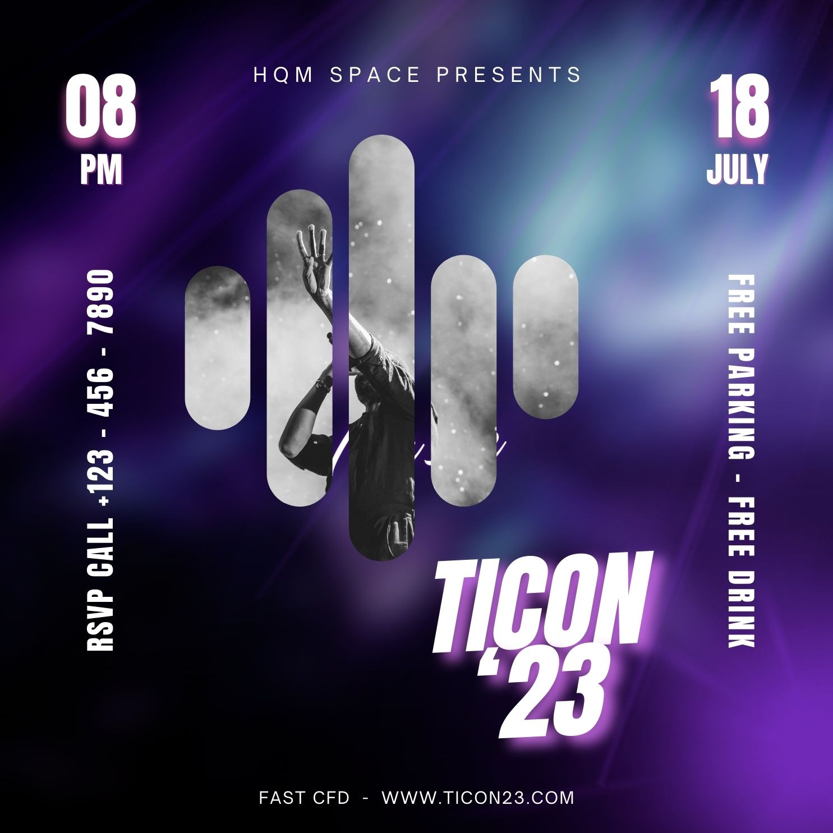

Table of Contents

**Introduction1**

**Key Features:** 2

**Collaborative Effort:** 3

HomeFunctionality**4**

USER FUNCTIONALITY 5

ADMIN FUNCTIONALITY 6

# SHEDULING FUNCTINALITY

20

# Introduction :

Welcome to TICON 23, a comprehensive Management System Project crafted with a user-friendly Windows Form interface and a robust Oracle database backend. Developed collaboratively by the talented team members Muhammad Bilal, Muhammad Haaris, Abdullah Jabbar, and Mustafa Baig, TICON 23 brings efficient and organized management to a variety of tasks.

**Key Features & Basic Overview:**

1. **User-Friendly Interface:** The project revolves around an intuitive Windows Form UI that simplifies complex operations into user-friendly interactions. Navigating through various functionalities is seamless and straightforward.
2. **Role-Based Access:** TICON 23 introduces a secure and role-based access system. Users can play different roles, such as admin, event creator, and participant, each with distinct capabilities and permissions. Password-protected login and signup forms ensure data security and integrity.
3. **Event Management:** Users can create events seamlessly through the platform. They can manage participant registrations, view event details, and schedule sessions. The system utilizes efficient Oracle database queries for insertion, deletion, and updating operations.
4. **Admin Control Center:** Administrators have extensive control over the system. They can generate insightful reports, manage user permissions, and oversee the scheduling of events. The system ensures that only authorized personnel can access and modify critical information.
5. **Additional Functionality - Sidebar Animation:** TICON 23 goes beyond the ordinary by incorporating an animated sidebar. This small yet engaging feature enhances the overall user experience, making navigation more visually appealing.

**Collaborative Effort:**

The project is a testament to the collaborative efforts of Muhammad Bilal Qureshi , Muhammad Haaris, Abdullah Jabbar, and Mustafa Baig. Their combined skills and dedication have resulted in a well-rounded Management System that caters to diverse needs in event management.

In conclusion, TICON 23 stands as a remarkable project with a user-centric design, robust database functionality, and additional features that elevate the user experience. Whether you're an event organizer, administrator, or participant, TICON 23 has something valuable to offer.

# (Mainform)

1. **Home Functionality:**
   * **Description:** The Home functionality serves as the starting point for users and administrators.
   * **Implementation:** Clicking on the Home tab could lead to a dashboard or overview screen, providing a quick glance at important information or upcoming events. It acts as a central hub for users to navigate to other sections of the application.
2. **User and Admin Tabs:**
   * **Description:** The User and Admin tabs suggest a role-based access system, allowing different functionalities based on the user type.
   * **Implementation:** Users, upon logging in, might see tabs or sections specific to their roles. For example, participants might have access to event registration, while administrators can access user management and event planning features.
3. **Scheduling of Events and Sessions:**
   * **Description:** This functionality indicates the ability to schedule events and sessions within the application.
   * **Implementation:** Clicking on the Scheduling tab could open a calendar or planner interface where administrators can create, edit, and manage events. This may also include the ability to schedule specific sessions or speakers for each event.
4. **Help Functionality:**
   * **Description:** The Help functionality suggests a support or information section for users seeking assistance.
   * **Implementation:** Clicking on the Help tab might open a section with FAQs, tutorials, or contact information for support. It's a valuable resource for users to find answers to common questions or get in touch with the support team.
5. **Details of Our Team:**
   * **Description:** This feature provides information about the development team behind TICON 23.
   * **Implementation:** Clicking on a "Team" or "About Us" section could display profiles, roles, and possibly contact information for each team member. It's a way to showcase the talents and contributions of the development team.

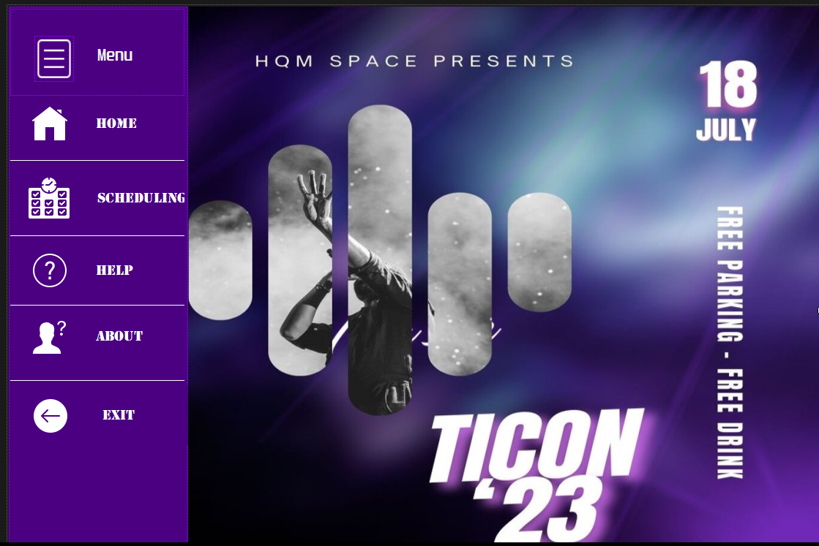

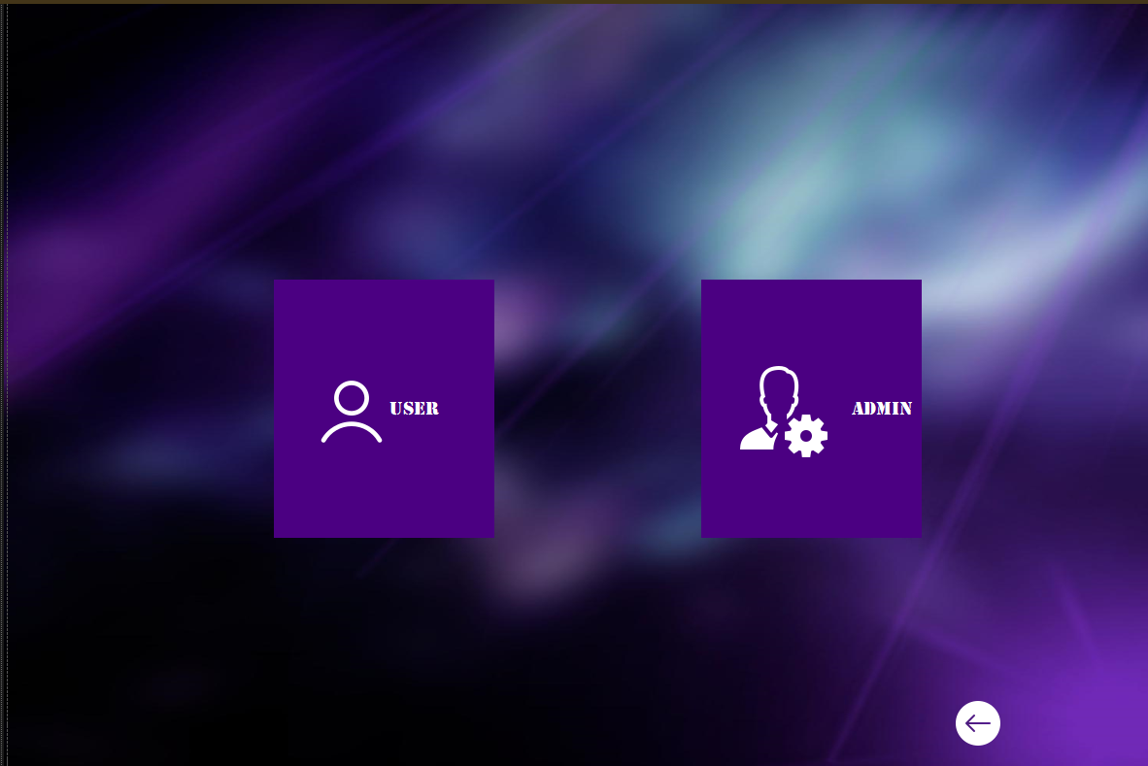

# USER FUNCTIONALITY

1. **User Authentication System:**
   * **User Login:**
     + Users can log in using their credentials.
     + Login form with fields like username and password.
     + Password protection for secure access.
   * **User Signup:**
     + New users can create accounts.
     + Signup form with required details (username, password, etc.).
     + Password protection and validation during signup.
   * **Database Integration:**
     + User data stored in the User table in the database.
2. **Event Management System:**
   * **Creating Events:**
     + Users can create new events.
     + Separate table in the database for event details.
   * **Managing Participants:**
     + Users can register and manage participants for their events.
     + Participants' data stored in a dedicated Participants table.
   * **Managing Event Details:**
     + Users have the ability to manage and update event details.
     + SQL queries for updating event information in the database.
   * **Database Integration:**
     + Event and participant data are stored in their respective tables in the database.
     + SQL queries for data retrieval, insertion, and updates.
3. **Login and Signup Forms:**
   * **Login Form:**
     + Enables users to log in with their credentials.
     + Password-protected access to ensure security.
   * **Signup Form:**
     + Facilitates new user registration.
     + Password protection and validation for data integrity.
4. **Password Protection and Security:**
   * **Hashing and Encryption:**
     + Implementing password hashing for secure storage.
     + Encryption techniques to protect sensitive information.
5. **Database Connectivity:**
   * **SQL Queries:**
     + Utilizing SQL queries for data manipulation (insert, update, delete).
     + Ensuring proper database connections for seamless integration.

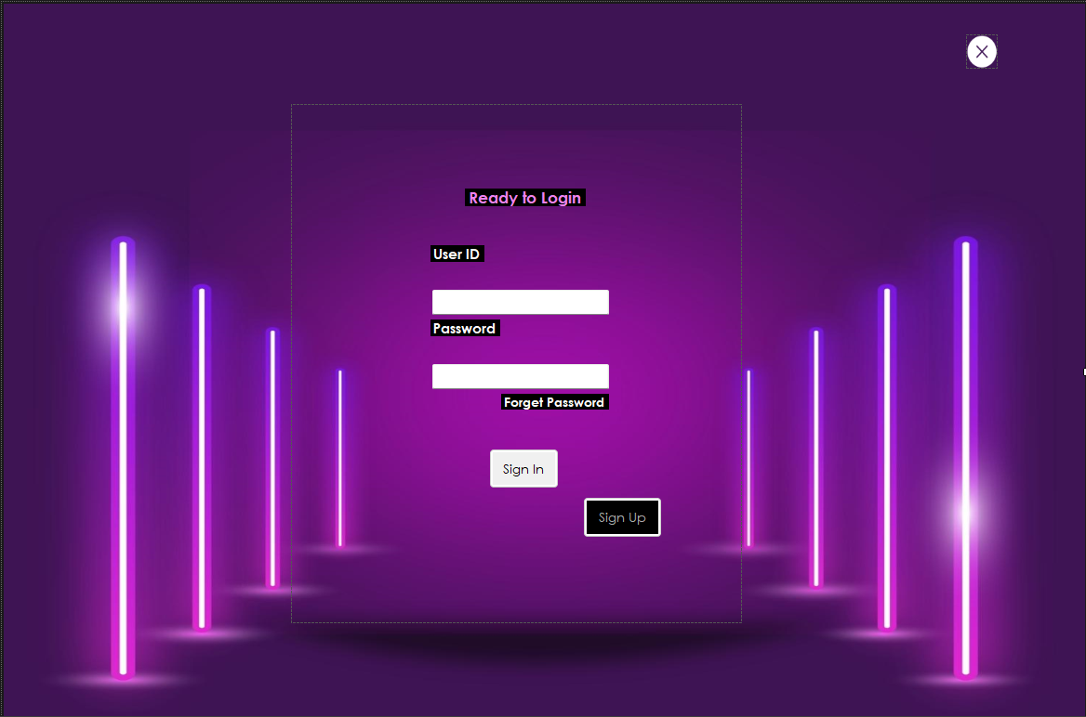

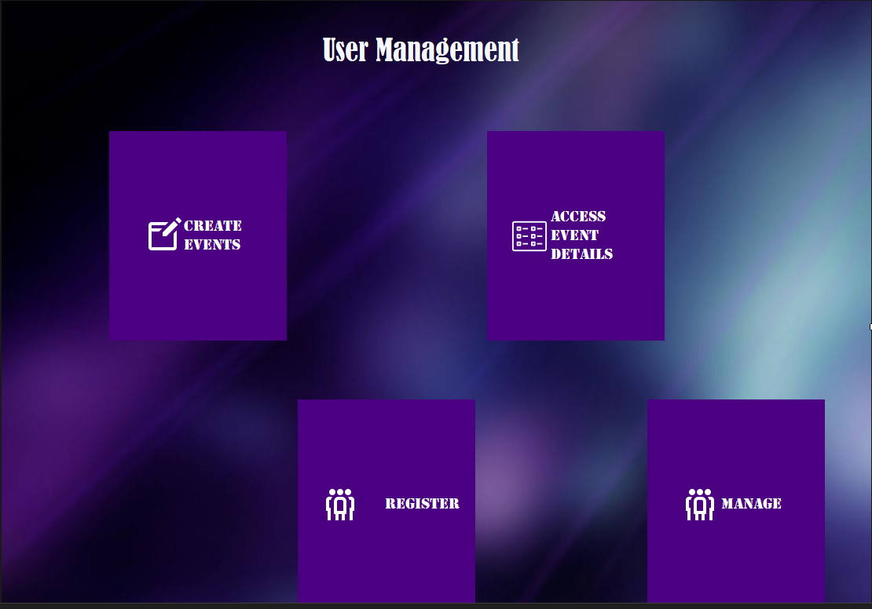

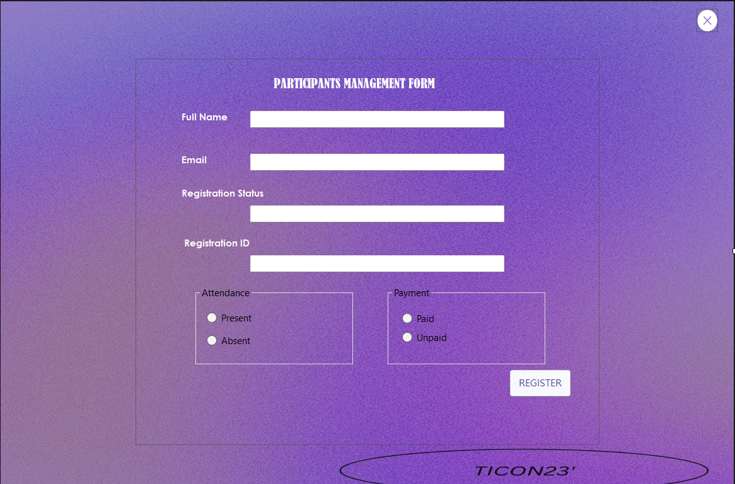

Everything is connected to database

# ADMIN FUNCTIONALITY

1. **Admin Authentication System:**
   * **Admin Login:**
     + Admins can log in with their credentials.
     + A login form with fields like username and password.
     + Password protection for secure access.
   * **Admin Signup:**
     + Admins can create accounts if needed.
     + A signup form with required details (username, password, etc.).
     + Password protection and validation during signup.
   * **Database Integration:**
     + Admin data stored in the Admin table in the database.
2. **Admin Functionalities:**
   * **Delete User:**
     + Admins can delete a user from the system.
     + SQL query to remove the user from the User table.
   * **Assign Role to User:**
     + Admins can assign roles to users, determining their permissions.
     + For example, granting the ability to create events or not.
     + SQL query to update the user's role in the database.
   * **Show Participants with Registered Events:**
     + Admins can view a list of participants along with the events they are registered for.
     + SQL query to retrieve participant and event data.
   * **Generate Reports:**
     + Admins can generate reports on the attendance status of participants (absent, present, enrolled).
     + SQL queries to fetch and organize data for reporting.
3. **Password Protection and Security:**
   * **Hashing and Encryption:**
     + Similar to user authentication, ensure password hashing and encryption for admin credentials.
     + Strengthen security to protect sensitive admin information.
4. **Database Connectivity:**
   * **SQL Queries:**
     + Utilize SQL queries for admin-related functionalities (deleting users, assigning roles, generating reports).
     + Ensure proper database connections for seamless integration.
5. **Exception Handling:**
   * Implement robust exception handling to manage errors gracefully.
   * Handle scenarios where data might not be found or operations fail.
6. **Role-Based Access Control:**
   * Ensure that only administrators have access to these functionalities.
   * Implement role-based access control to restrict access to sensitive admin features.

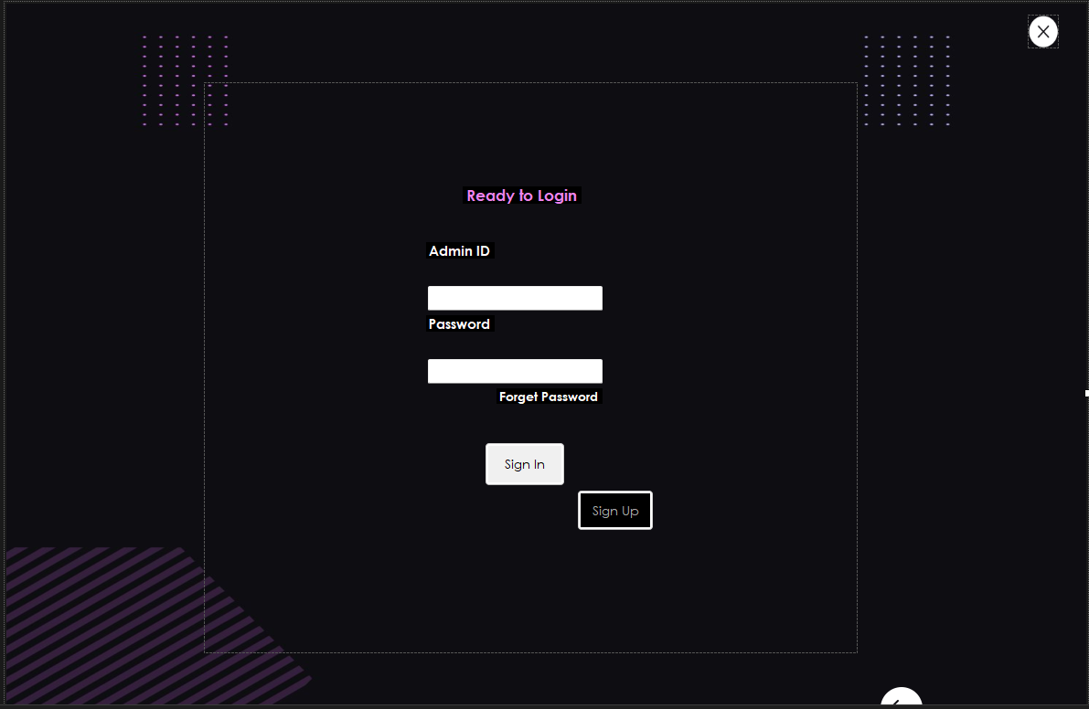

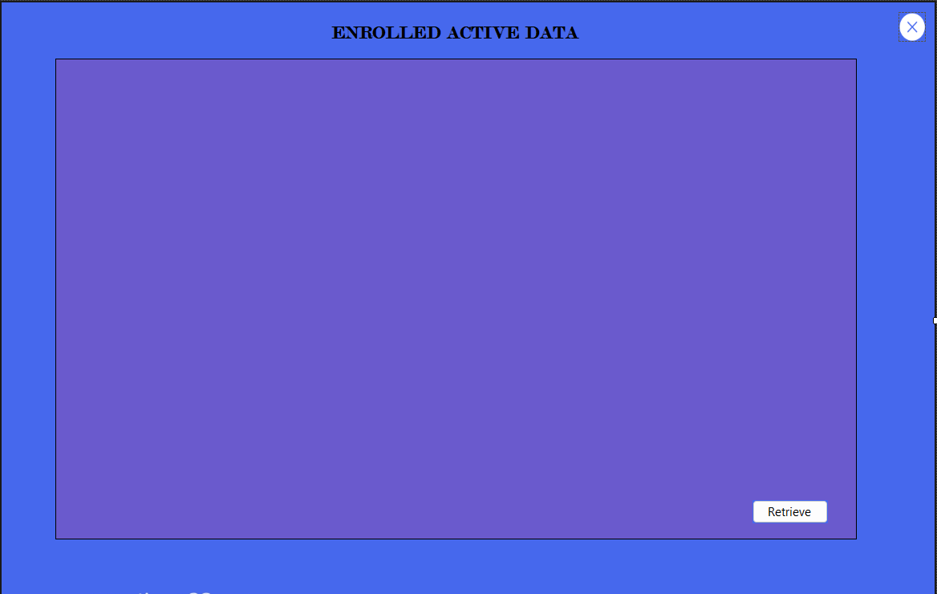

# SHEDULING FUNCTINALITY

1. **Scheduling Functionality:**
   * **Assign Schedules to Events:**
     + Admins can assign schedules to specific events.
     + Define the date, time, and possibly the venue for each scheduled event.
     + Use a form or calendar interface for admins to input scheduling details.
   * **View and Manage Event Schedules:**
     + Admins have the ability to view and manage existing schedules.
     + List all scheduled events with their corresponding dates and times.
     + Allow modification or deletion of schedules if needed.
   * **Participant Session Schedules:**
     + If events consist of multiple sessions, admins can assign schedules for each session.
     + Associate participants with specific sessions if required.
   * **Notification System:**
     + Implement a notification system to remind participants and admins of upcoming scheduled events.
     + Send email notifications or in-app alerts for scheduled events.
   * **Integration with User Roles:**
     + Coordinate with the role-based access control system.
     + Admins with specific roles may have different scheduling privileges.
   * **Database Integration:**
     + Create a Schedules table in the database to store scheduling information.
     + Use SQL queries to insert, update, or retrieve schedule data.
2. **User Interaction:**
   * **User-Friendly Interface:**
     + Design an intuitive interface for admins to interact with the scheduling feature.
     + Ensure easy navigation and input for scheduling details.
   * **Accessibility for Event Organizers:**
     + If event organizers have specific roles, they can be given access to schedule their own events.
     + This ensures a distributed responsibility for scheduling.
3. **Reporting and Analytics:**
   * **Scheduled Event Reports:**
     + Generate reports showing scheduled events and associated details.
     + This can aid in planning and coordination.
   * **Attendance Reports:**
     + Correlate schedules with attendance data to generate insightful reports.
     + Identify trends, popular time slots, or any scheduling-related patterns.
4. **Integration with Calendar Tools:**
   * **Export to Calendar Apps:**
     + Allow admins to export scheduled events to standard calendar applications.
     + Enhances integration with personal calendars for better time management.
5. **Flexibility and Adaptability:**
   * **Dynamic Scheduling:**
     + Design the scheduling system to be flexible and easily adaptable.
     + Support changes to schedules without disrupting other functionalities.

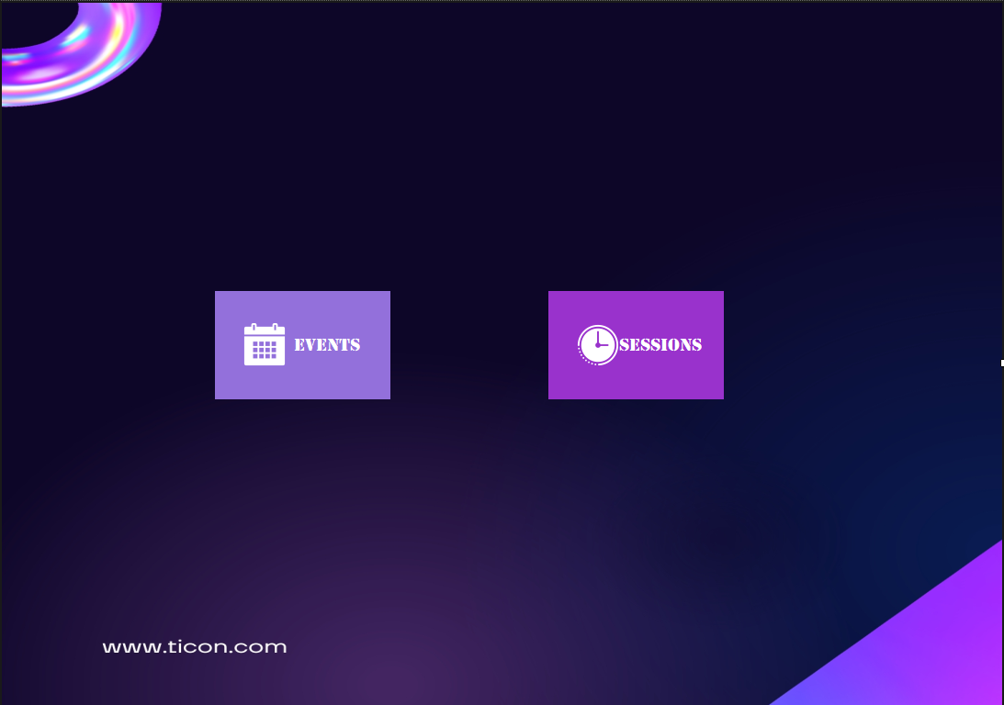

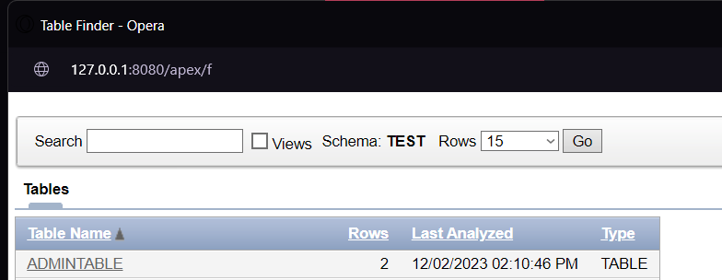

TO SHOW THE WORKING OF THE PROJECT I AM ATTACHING A VIDEO

I AM ATTACHING ALL THE LOGOS, BACKGROUND IMAGES AND STUFF TO MAKE THIS PROJECT.

## GROUP MEMBERS

Muhammad Bilal Qureshi 21-f9066

Muhammad Haaris Changez 21-f9060

Abdullah Jabbar 21-F9239

Mustafa Baig 21F-9257